

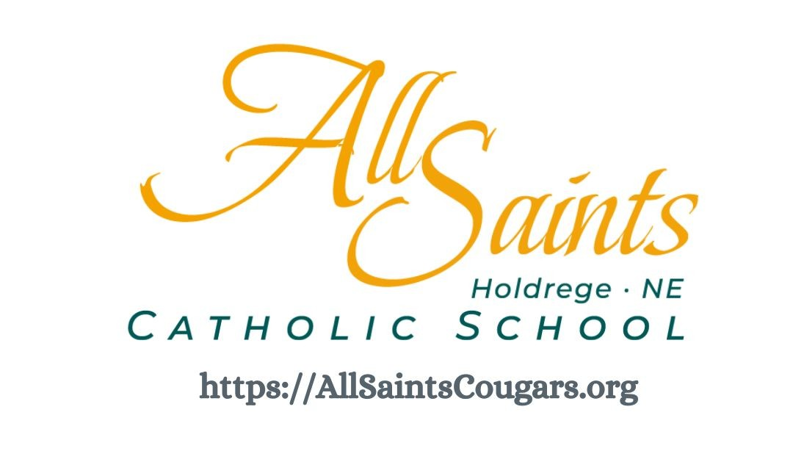

2025 – 2026
ANNUAL REPORT

PURPOSE OF THIS REPORT
The 2025 – 2026 annual report is submitted to All Saints Catholic School families and stakeholders in accordance with Rule 14 of the Nebraska Department of Education. The report will include student performance, school demographics, and financial information.

MISSION STATEMENT

Responding to God’s call, we, the community of All Saints Catholic School, dedicate ourselves with love to the spiritual growth and academic excellence of our children to prepare them for the journey through this life to the Kingdom of Heaven.

EDUCATIONAL PHILOSOPHY

All Saints Parish established a Catholic School in 2001 in order to fulfill, in part, the mandate of Christ to teach the Gospel to the whole world. All Saints Catholic School offers students an education based upon Catholic doctrine which is intended to help students acquire the knowledge, values, skills, and attitudes necessary to find meaningful purpose in life and for eternity. Recognizing the unique abilities and talents of each child, the school strives to develop the whole person—spiritually, intellectually, culturally, physically, and socially. Our school exists to help each child, under the guidance of the Holy Spirit, develop those attitudes, values, and behaviors which move them to become a lifelong Catholic witness and provide them with the necessary skills enabling them to be responsible citizens.

CERTIFIED STAFF

STAFF MEMBER | EDUCATION LEVEL | YEARS OF EXPERIENCE | POSITION
Justin Luthy | B.A. | 14 | Head Teacher  3rd & 4th Grades
Jill Gillespie | B.A. | 3 | Kindergarten
Kim Gillespie | B.A. | 27 | 1st & 2nd Grades
Melinda Pelster | B.A. | 22 | 5th & 6th Grades
Starla Berry | B.A. | 4 | Music/Band
Ramona Peterson | M.A. | 14 | Art
Ashley Popple | B.A. | 5 | P.E.

CLASSIFIED STAFF

STAFF MEMBER | POSITION
Deb Corkery | Administrative Assistant
Jannelle Pfeifer | School Secretary
Kazia Nelson | Preschool
Mary Sue Newth | Preschool Aide
Megan Weisheit | Instructional Aide
Sara Hill | Lunchroom Staff
January Aldinger | Librarian
Heather McQuillan | Guidance Counselor

ENROLLMENT

Grade | Female | Male | Total
PK | 1 | 6 | 7
K | 3 | 2 | 5
1st | 7 | 6 | 13
2nd | 2 | 2 | 4
3rd | 9 | 2 | 11
4th | 5 | 4 | 9
5th | 4 | 6 | 10
6th | 3 | 1 | 4
Total | 34 | 29 | 63

Academics
All Saints is led by 1 head teacher, 3 classroom teachers, and 3 specials teachers, our students engage in an academic program following standards from the Lincoln Diocesan Education Office and the Nebraska State Standards. Daily religious education and Mass attendance helps to integrate faith formation throughout the day.
Students are tested to gauge their academic progress using the Iowa Test of Basic Skills (ITBS). The ITBS results are summarized in the table found below. The results given are for the 2024-2025 school year for grade equivalency.

Grade | ELA Total | Math Total | Social Studies | Science | Class Average
3rd | 4.7 | 4.2 | 4.4 | 5.0 | 4.5
4th | 6.1 | 5.6 | 6.2 | 6.5 | 6.3
5th | 7.3 | 6.2 | 6.6 | 6.5 | 6.6
6th | 10.2 | 9.0 | 9.4 | 9.6 | 9.5
**Note: Grade equivalency corresponds to a given standard score indicating the grade level and number of months of instruction at which the typical student has obtained this score.
Interpreting Results – Analyzing norm-referenced results against the national norms is difficult with class sizes averaging between 6-10 students.

Learning and Growing Beyond the Classroom
Throughout the school year, All Saints’ students engage in many events and activities that take learning beyond the walls of the traditional classroom. The fourth through sixth graders are invited to be a part of HAL – High Ability Learners - and Quiz Bowl. They also participate in the Invention Convention. The fifth and sixth graders are invited to join Band here at the school.
The school participates in creating and giving out signs and cards to members of the community. They participate in diaper and food drives, they also make quarterly visits to a local nursing home near the school.
All Saints students participate in many other learning opportunities throughout the year. A mentor program pairs our 3rd and 4th graders with our Kindergarteners, meeting regularly to learn and work together, and classes take field trips throughout the year to reinforce learning in the classroom with outside/real-world experiences.

